A LOW POWER MODULAR WIRELESS SENSOR NETWORK

by

Krikor Hovasapian
Nikita Agarwal

Students of Bachelor of Computer Engineering
University of Nevada – Las Vegas
2004

Faculty Mentor
Dr. Biswajit Das

Instructor
Bill O’ Donnell

A final report submitted for fulfillment
Of the requirements for the

Senior Design Project in Computer Engineering
Department of Electrical and Computer Engineering
Howard R. Hughes College of Engineering

University of Nevada, Las Vegas
December 2004

TABLE OF CONTENTS

ABSTRACT………………………………………………………………………........................3
ACKNOWLEDGEMENTS……………………………………………………………………….4
INTRODUCTION………………………………………………………………………………...5
PROBLEM DESCRIPTION………………………………………………………………………9
BACKGROUND AND HISTORY………………………………………………………………10
CONSTRAINT ANALYSIS …………………………………………………………………….11
PART ANALYSIS……………………………………………………………………………….13
BLOCK DIAGRAM……………………………………………………………………………...17
FLOWCHART - MATER NODE ……………………………………………………………….18
FLOWCHART – SLAVE NODE ………………………………………………………………19
FLOWCHART-PDA……………………………………………………………………………..20
FLOWCHART-GPS UNIT………………………………………………………………………21
DESCRIPTION OF THE FLOW CHARTS ……………………………………………………..22
POWER CALCULATIONS……………………………………………………………………...26
SCHEMATICS…………………………………………………………………………………...29
ECONOMIC ANALYSIS………………………………………………………………………..31
SAFETY ETHICS AND HEALTH ISSUES…………………………………………………… 33
AESTHETICS…………………………………………………………………………………….35
SUSTAINABILITY………………………………………………………………………………36
MANUFACTURABILITY……………………………………………………………………….37
SOCIAL, POLITICAL AND ENVIRONMENTAL IMPACT…………………………………..37
FUTURE WORK…………………………………………………………………………………38
CONCLUSIONS………………………………………………………………………………….38
REEFERENCES………………………………………………………………………………….39
APPENDIX………………………………………………………………………………………40
ABSTRACT

A Low Power Modular Wireless Sensor Network
by
Krikor Hovasapian
Nikita Agarwal

Dr. Biswajit Das, Faculty Mentor
Professor of
Department of Electrical and Computer Engineering
University of Nevada, Las Vegas.

The project develops a low power modular sensor network for real time monitoring of environmental parameters, temperature, pressure, humidity and location (through a GPS unit). The project puts together three nodes and a PDA for output display: One Master node, and two slave nodes forming a Piconet. The master node consists of a power, communications, and a data and control module. The slave nodes consist of the same modules in addition to the sensor modules.
The communication module is a Bluetooth module (a wireless transmitter unit with an antenna). The data and control unit consist of a PIC microcontroller 16f877 and a multiplexer. The power module consists of a 6V camera battery, two sharp voltage regulators and a RS232 unit. The sensor module consists of temperature, pressure, humidity and a GPS unit. The sensor data is collected on the slave nodes is send over to the master node via the Bluetooth which is transmitted to the PDA for display.

ACKNOWLEDGEMENTS

We would like to thank Dr. Biswajit Das for giving us an opportunity to work on a project under his supervision and guiding us from then on to the successful completion of this project. We appreciate his understanding and support during the course of our project. We thoroughly enjoyed working on the project under his direction.
We thank our instructor Bill O’ Donnell for guiding us and providing us with valuable suggestions and corrections. We would like to thank the Engineers at Bechtel for providing Krikor with extremely valuable suggestions during his course of internship in summer ’04 at Bechtel, Nevada.
We would like to express our gratitude to the continued support of our families to pursue a study of our choice, with constant encouragement and care all the way. We would like to make a special mention about our friends at UNLV, and everyone in the ECE department for all the support, affection, and guidance through our course of study and completion of the project.
Lastly, we would like to acknowledge each other for putting up with each other during the numerous courses taken together in the last three years and during the course of the project completion.

INTRODUCTION
Wireless Technology – Bluetooth Protocol
Bluetooth is a communication device that is used for applications, which have low power requirements. The device operates within the 2.4GHz range of the ISM band and can operate under three different classes: Class 1, Class 2, and Class 3. Class 1 is a long-range implementation that can communicate with other Bluetooth devices within a distance of 100 meters, while the other classes, 2 and 3, operate at up to 30 meters and 10 meters respectively. The transmission rate can vary from class to class. For example, a class 2 network of 30 meters can transmit at approximately 720 kbps. If the device is extend past the
A piconet is what creates a Bluetooth network. In order for the network to operate, there must be at least one master and two slaves to form a piconet. The piconet will allow up to seven devices in one network and the nodes can interchange from one piconet to the next. This interchanging is what’s called a scatternet. Scatternets occur when two or more piconets are connected to each other. The advantage of this implementation is having “scattered” nodes all across a range that would normally confine one node to its limited distance capacity. Data can travel from one point to many points and get to a further destination without having to increase the gain (dB) between a master and its slaves and thus increasing the power output that could diminish the purpose of a low power design.
An RF-Module can be a simple point-to-point connection, which limits the flexibility of an embedded design. Bluetooth enhances the performance of a regular RF-module by including a protocol stack that can allocate resources such as memory to do tasks such as point-to-multipoint. Using the Time Division Multiplexing algorithm, a master device can give any node approximately 620 microsecond (us) to transmit data within that window time frame. Upon expiration of that frame, the master “hops” to the next node and allows the same amount of time. This “hopping” continues until all data is routed properly to the master node. The beauty of this technology is made evident by this illusion of parallel processing. The human eye will think that all data is sent simultaneously, but in reality the speed of the data transmission is faster than the eye can really follow. Therefore, efficient use of resources on the Bluetooth module is priority one.
All-in-all Bluetooth is a rapidly growing technology that will continue to make an impact in any industry that seeks a low power, RF module implementation in their design. As new products come about (i.e. cellular phones, portable digital assistants, televisions, etc.) we can see how companies are continuing to re-invent their designs around this marvelous device.
GPS – Global Positioning System
In 1973, the Department of Defense satellite navigation or the Global Positioning System, composed of 24 Navstar satellite, each weighing some 1,900 lb. Each satellite orbits the earth every 12 hours in a formation that ensures that every point on the planet will always be in radio contact with at least four satellites. The first operational GPS satellite was launched in 1978, and the system reached full 24-satellite capability in 1993.
Each satellite continuously broadcasts a digital radio signal that includes both its own position and the time, exact to a billionth of a second. A GPS receiver takes this information--from four satellites--and uses it to calculate its position on the planet. The receiver compares its own time with the time sent by a satellite and uses the difference between the two times to calculate its distance from the satellite. By checking its time against the time of three satellites whose positions are known, a receiver could pinpoint its longitude, latitude, and altitude.
The receiver has to know exactly where the satellites are and the satellites have to be able to keep reliable and extraordinarily accurate time. Accuracy is ensured by having each satellite carry four atomic clocks. Reliability is ensured by the satellites' 11,000-mile-high orbits, which put them far above the atmosphere and keep them moving in very predictable trajectories. The Department of Defense monitors the satellites as they pass overhead twice a day and measures their speed, position, and altitude precisely. That information is sent back to the satellites, which broadcast it along with their timing signals. GPS provides highly accurate, real-time, all-weather position, velocity, and time data.
The National Marine Electronics Association (NMEA) has developed a specification that defines the interface between various pieces of marine electronic equipment. GPS receiver communication is defined within this specification. Most computer programs that provide real time position information understand and expect data to be in NMEA format. This data includes the complete PVT (position, velocity, time) solution computed by the GPS receiver. The idea of NMEA is to send a line of data called a sentence that is totally self contained and independent from other sentences. There are standard sentences for each device category and there is also the ability to define proprietary sentences for use by the individual company

Decode of selected position sentences
The most important NMEA sentences include the GGA which provides the current Fix data, the RMC which provides the minimum GPS sentences information, and the GSA which provides the Satellite status data.
GGA - essential fix data which provide 3D location and accuracy data. For an example
$GPGGA,123519,4807.038,N,01131.000,E,1,08,0.9,545.4,M,46.9,M,,*47
GGA Global Positioning System Fix Data
123519 Fix taken at 12:35:19 UTC
4807.038,N Latitude 48 deg 07.038' N
01131.000,E Longitude 11 deg 31.000' E
1 Fix quality: 0 = invalid
1 = GPS fix (SPS)
2 = DGPS fix
3 = PPS fix
4 = Real Time Kinematic
5 = Float RTK
6 = estimated (dead reckoning) (2.3 feature)
7 = Manual input mode
8 = Simulation mode
08 Number of satellites being tracked
0.9 Horizontal dilution of position
545.4,M Altitude, Meters, above mean sea level
46.9,M Height of geoid (mean sea level)
*47 the checksum data, always begins with *

PROBLEM DESCRIPTION
Wireless Technology is an advancing science, which provides a promising future. We decided to pursue wireless as the theme of our project so we could develop an insight in wireless communications for the purposes of future study and work in this area.
On a grander view, our project is a Wireless Sensor Network system envisioned by Dr. Das which includes a method of worldwide communication between a host and client. The clients monitors and collects the data and relays it to the host for display. The upgrade can be a CDMA add-on module to allow a client from any where in the world, access to the data that’s being stored on the master device.
Through the means of our project we have demonstrated the working of a piconet using Bluetooth, which forms the first prototype of the grand design. One piconet can be formed with upto seven slaves and a master and similar set ups with more than one master nodes enabling each node to pursue mutual communication. Grouping of more than one master or more than one piconet forms a scatternet. The immediate upgrade to the project would be to form a scatter net.
To sum up, in this project we have built the first prototype of the grand design. We have a system which monitors the environmental parameters temperature, pressure, humidity and location (through GPS) and sends it wirelessly through Bluetooth to the master node and over to the PDA for display.

BACKGROUND AND HISTORY

Wireless Sensor Networks is a highly researched field in Wireless Communications. We have come across many forms of wireless sensor networks. Most of the sensor networks use RF or point to point communications and use a computer, or a HyperTerminal for display.
In our design we have tried to come up with an all-in-one design, wherein the user can use a low power small module for monitoring various sensor data and can see the data handy on a PDA. This is a module of its kind in proving weather conditions and location in one design. Additionally, it is extremely easy to use, no internet is required, lightweight, and discreet and up gradable and low power consumption.
We can develop, multipoint communications unit with the same setup, which would improve the marketability remarkably.

CONSTRAINT ANALYSIS
- Wireless Communications
We had limited knowledge of the J2ME (Palm OS) vs eMbedded Visual C++ , required for communication between the PDA with the master node. We also had limited knowledge about Bluetooth protocol, stack implementation and programming a Bluetooth device. We did a lot of online research and the book entitled “Programming Microsoft Windows CE.NET” by Doug Boling helped us a lot.
- Cost
Bluetooth is an advancing technology and most of the modules available are quite expensive for College students.
- Life cycle of products
We had to make the WSN a low power device, to minimize battery requirements and replacement. Most of the other components have negligible wear and tear and stay good for a long time.
- Modular design
The WSN should be a modular design so the parts could be upgraded to increase efficiency, and replaced as per the requirements. The Bluetooth as I said earlier is an advancing technology. New modules are introduced regularly with better range and efficiency. Also, more sensors can be added to the existing design and available ports.
- Choice of products
Bluetooth Module
Range and Efficiency were important factors in order to choose the correct module. We had to pick up a module which could provide us with visible results, power efficiency, ease to use etc. We came across a module the national LMX980. This particular IC required the mounting of a ball grid array which is quite difficult to implement.

Battery
Battery life is an important factor for a wireless module. Although the WSN is a low power device, the battery has to be recharged or replaced regularly.
6. Physical Size
It is important for the WSN to be as compact and as light weight as possible for practical purposes of ease of use and application.

PARTS ANALYSIS

- Bluetooth Module
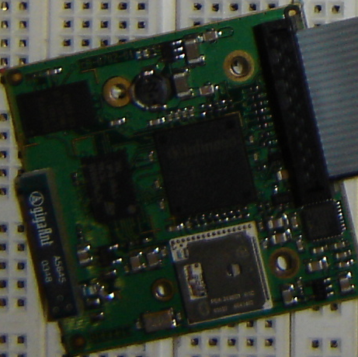
- Bluetooth – Connect Blue
- All in one design
- Low Power Unit
- Package design with on-board antenna
- Uses UART technology
- Requires minimal overhead

Alternatives and Weights

Bluetooth Module | Cost | Range | Overhead
ConnectBlue | $185 | 100 m | Minimal Overhead, easier learning curve
National | $60 | 30 m | Four layer PCB, Mounting ball grid array, and assembling antenna and other external RF components
Casira | $4000 | 10 m | Full construction of the module, programming the Bluetooth stack, embedding it with RF etc.

- GPS unit
  - Falcom JP3
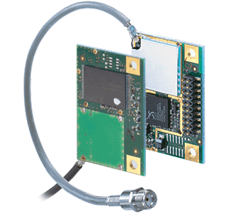
  - Embedded system design
  - Compact
  - With external antenna attachment
  - Low Power = 0.2 W
  - 3.3 V à 65mA
  - Minimum overhead

Alternatives and Weights

GPS Unit | Design | Size | Mounting | Power
JP3 | Embedded | 1” X 1” | PCB mounted | Trickle mode
JP7 | Embedded | 2” X 2” | Requires PCB | Trickle mode
Garmin | Box | 5” X 2” | Box | No trickle mode

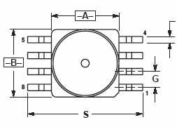
- Pressure Sensor

  - Motorola - MPX4115A
  - Embedded system design
  - Compact
  - With external antenna attachment
  - Low Power = 0.2 W
  - 3.3 V à 65mA
  - Minimum overhead

Alternatives and Weights

Pressure | Cost | Type | Current | Accuracy | Communication | Sensitivity
MPX4115A | $25 | Analog | 7 mA | + 2% | A/D on PIC | 45.9mV/kPa
DSDX | $33 | Digital | 6 mA | + 2% | I2C | 10mV/kPa
MPX4250A | $30 | Analog | 8 mA | + 3% | A/D on PIC | 50mV/kPa

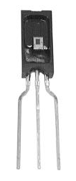
- Humidity Sensor
  - Honeywell - HIH-3610-001
  - Uses the A/D conversion of PIC
  - Comparatively cheaper than digital sensors
  - Accuracy - + 2%
  - Operating Temperature: -40 °C to +85 °C
  - Operating Humidity Range: 0 to 100% RH
  - Low Power: 5V ~ 200uA = 1mW

Alternatives and Weights

Sensor | Price | Type | Package | Current | Response Time | Accuracy
HIH 3610 | $25 | Analog | Dip | 200uA | 15s | + 2% RH
Sensiron SHT II | $30 | Digtial | SMD/Dip | 550uA | <3sec | + 3% RH

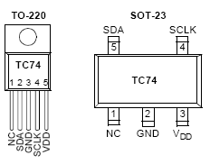
- Temperature Sensor
  - Microchip TC-74
  - Digital Sensor – T0220 Packaging
  - Uses I2C serial port interface
  - Range: -40 to +125 Degree Celsius
  - Accuracy: + 3%
  - Low Power: 5V ~ 200uA = 1mW
  - Low Cost – Free Samples available

Alternatives and Weights

ensor | Price | Type | Package | Accuracy | Range | Current
TC74 | Free | Digital | Dip | + 2% | -40 to +125°C | 200uA
DS75 | Free | Digital | SMD | + 2% | -55 to+125 °C | 1000uA

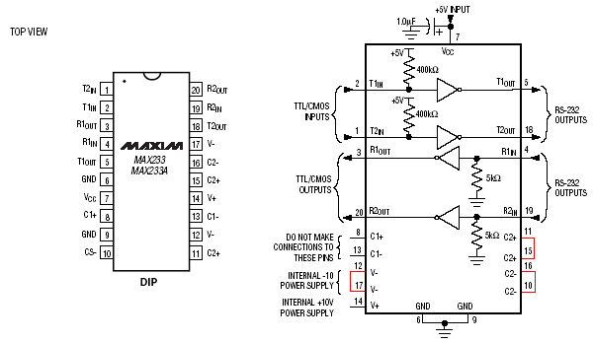
- Max – 233 (up converter – down converter)
  - Used as an up converter and down converter of RS232 logic levels.
  - Internal capacitors: needs no extra components
  - Used between the Bluetooth Module and the PIC
  - Converts 5V from the PIC to 10V of Blue Connect

Alternatives and Weights

IC | Price | External Components | Input Hysteresis | Input Current | TPHL/  TPLH | Slew Rate
MAX 233 | $2 | none | 0.5-1V | 15uA | 1.3/1.5us | 12V/us
MAX 232 | $5 | 4  capacitors | 0.5-1V | 15uA | 1.3/1.5us | 12V/us

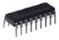
- Multiplexer – 74LS157N
  - Propagation delay of 9 ns
  - Inputs: 1.Tx/Rx line
2. SELECT line
  - When the select line goes to 0,
The Bluetooth gets chosen, while 1 goes to the GPS

Alternatives and Weights

We did not look into many multiplexers. This IC was available in the lab and we picked it up for testing. It worked perfectly with out system so we decided to go with it.

- Microcontroller
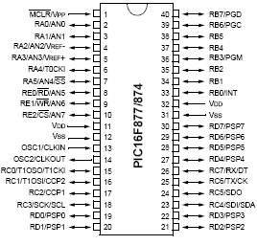
  - PIC-16f877
  - 40 pins
  - On board A/D conversion
  - UART port, on board I2C conversion
  - Low Power goes to sleep mode

Alternatives and Weights

We picked up PIC 16F877 as we are familiar with the PIC through a series of labs and classes which use the same PIC. It is perfect for our project as it a low power device. It has 40 pins, has on board A/D conversion, I2C communication and a UART port.

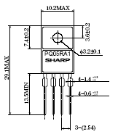
9. Voltage Regulators

  - Sharp: PQ05RA1 6 V à 5V Output and
  - PQ033EF0152 6 V à 3.3 V Output
  - Discrete – no extra components required
  - Low Power Loss. Dropout voltage max = 0.5V

Alternatives and Weights

Voltage Regulator | Power  Loss | Precision | Junction Temperature | Output Current | External Components
PQ05RA1 | Max: 0.5 V | + 2.5% | 150 °C | 1A | None
LM2575 | Max: ~1V | + 3% | 150 °C | 1A | Inductors, Zener Diodes, Capacitors

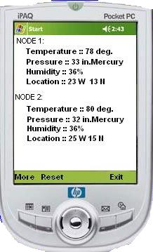
10. PDA – HP IPAQ - 1945
- Embedded Bluetooth
- Uses Window CE 4.0
- 64 MB of RAM
- Programmed with eMbedded Visual C++

Alternatives and Weights

No clear cut winner, but mostly something simple. We wanted a device that had integrated Bluetooth and was cheaper than the competitor at the time of purchase. The palm is a nice PDA and allows us to use J2ME (Palm OS) vs eMbedded Visual C++ (WINCE/POCKET PC). We are familiar with C/C++, therefore we chose the Pocket PC.

BLOCK DIAGRAM OF THE WSN - WIRELESS SENSOR NETWORK

MASTER

SLAVES
Master
Wakes up
Wakes up
The slaves
Approx 1
Sec delay
Send to
PDA
Request
Pressure
Request
Humidity
Wait
State
SLAVES
Wake up
Request
GPS Data
Send to
Sleep

Master
Sleeps
PDA Start

Wake up
Master

Read Thread

Output To
Screen
Display
Final Results
Get
Temp
Wait
State
Get
Pressure

Wait
State
Get
Humidity
Wait
State
Get
GPS
I2C
A/D

Send to
PDA
Send to
PDA
Send to
PDA
A/D
UART
Port

Request
Temperature

Wait
State
Sleep
FLOWCHART OF THE MASTER NODE

ON
Sleep
RB4/INT?

Wake
up Slaves
Wait
Delay
Receive data from all nodes
Store data into variables
RCIF
High
Request
Temp Data
Request Pressure Data
RCIF
High
Store data into variables
Receive data from all nodes
Store data into Variables
RCIF
High
Request Humidity Data
Request
GPS Data
RCIF
High
Store data
into variable
Receive
data from all nodes
Receive Data from all Nodes
IF NO
IF NO
IF yes
IF yes
IF yes
IF NO
IF yes
IF yes
IF NO
IF yes
IF yes
IF NO

IF no

IF NO

FLOWCHART OF THE SLAVE NODE
Turn
ON
Initialize GPS
Sleep
RB4/int
?
Wait
State
Rcif
High ?
Goto
Cmd_Table
Check
CMD
Goto
Routine
Send
data
Routine
Temp
Pressure
Humidity
GPS

Call transmit routine

FLOWCHART OF THE PDA

Main
Message dispatch
Loop
<Heart of the Program>
Call
Bluetooth
Manager
Display BT services
in the area
Ok or
Choice of Bluetooth
Show
main window
Send wake up pattern
to choice
Call Read Thread
Show
Main Window
- Get data from
com5 (BT)
- display data on
Main window

Main
Message dispatch
Loop
<Heart of the Program>
CONNECT
ABOUT
EXIT
Main
Message dispatch
Loop
<Heart of the Program>
Show
About
Window
Write
To
Window
Show
Main Window
Main
Message dispatch
Loop
<Heart of the Program>
If Exit
Message
Exit and
Close
Applications

FLOWCHART OF THE GPS UNIT
Initially this is what happens with the GPS

Call VOID routine: Routine will send 115 bytes of data to GPS that will specify which formats are on and off. We only want GGA

GPS Responds

Every 5 seconds only GGA data is Streamed

PIC turns on

When the master requests for the GPS
Go back to
main loop for
further
instructions

Request for
GPS data by Master

PIC switches MUX. Listens on RX pin

RCIF SET HIGH?

MUX on GPS

Y

N

Every 5 seconds
GGA data is
pumped out of the GPS unit and back into the PIC

Read in
and Parse
Data

Send to Master

DESCRIPTIONS OF THE BLOBK DIAGRAMS AND THE FLOWCHARTS
1. BLOCK DIAGRAM OF THE WSN
1. The PDA turns ON. It wakes up the Master, the Master then wakes up the slaves.The slaves goto sleep mode and keep listening for a Port B interrupt. As soon as the change occurs, the slaves go in the receive mode and wait for a command from the Mater.
2. When the Port C interrupt occurs, the slaves jump out of the receive loop and goto to the CMD_Table to execute the information asked by the master. Like if asked for the temperature by the master, the slave would get the temperature data through the I2C communication and send it over to the master. For Pressure and Humidity data the slave would get the data through A/D conversion and send it over to the Master. For the GPS data the slave would switch to the UART port, collect the GPS data and send it over to the Master.
3. Data from the Master is send over to the PDA for output display. Then the Master puts the slaves to sleep and goes to sleep itself.
2. FLOW CHART OF THE MASTER MODULE
1. The PDA turns on the Master. The Master waits for the Port B interrupt. On the toggle it wakes up the Master. Then it waits for sometime or goes to the delay state.
2. The master then requests for the Temperature data from the slaves. The master waits for the RCIF to go high. Once it is high, it stores the temperature data into appropriate variables and collect the data from both the slave nodes.
3. Now it asks for the Pressure data. The same loop is repeated and in the next loop it asks for the Humidity data. The same sequence is repeated.
4. Lastly the Master requests for the GPS data and the at the RCIF high it stores the useful data into appropriate variables and voids the rest of the data. It collects the data from both the nodes and goes back to the sleep mode until the PDA wakes it up again.
3. FLOW CHART FOR THE SLAVE NODE
1. The master wakes up the slaves. After waking up, the slaves go in sleep mode where they are listening for a Port B interrupt.
- As soon as the Port B interrupt occurs, the slaves go in the receive mode and wait for a command from the Master.
- At the next interrupt when the RCIF goes high, the slaves receive the next command from the Master. The slaves compare the command from the command table and jump to the specific routine and get the desired data and send it over to the master.
- The master first asks for the temperature data, the slave gets the temperature through I2C communication and sends it to the master. The Master then asks for Pressure data, the slave gets it through A/D conversion on the PIC and sends it to the master. Master next asks for the Humidity data, the same process is repeated.
- The Master then finally asks for the GPS data. The slave switches to the UART port, and selects the GPS unit. The slave node then collects the GPS data and sends to the master.

4. DESCRIPTION OF THE PDA FLOWCHART
1.The PDA is set up in a way that requires user input by the stylus pen. The program runs but stays in one state, a continuous loop where messages are brought in by the OS to the Program and out is the heart of the program.
2. When the user interacts with the program by clicking on a menu or button, this sends out a message. So if the user hits View, then CONNECT, the program will open COM5 (where the Bluetooth resides) and the Operating System(Windows CE) will detect that a com port is being open, and in this case it's the Bluetooth Driver. So the OS responds by sending a viewer to the WSN program.
3. This viewer lists all the Bluetooth devices that are active and discoverable. When the operation times out, a list is produced and the user can select one of the listed devices.In this case, the device is "MASTER." The user selects Master, and instantaneously the program creates the Read Thread and when data comes in, the Read Thread organizes this data by filtering out unwanted bytes and keeping those that are necessary for the results in a separate memory buffer, or array. When the operation is terminated by the 9th ' * ' counted in the transport packets, the PDA stops the thread (to save power) and goes to the main window and back into the heart of the program which is the messaging. The program actually stays in the messaging section, and never leaves when the thread is running. When the thread stops, the only looping going on is in the messaging section of code.
4. ABOUT: click on ABOUT, a window is created, the window displays text about the program, and an OK button, click OK and go back to main window, or stay there.
5. EXIT: This says close all applications and exit.
5. DESCRIPTION OF THE GPS UNIT FLOW CHART
- When the slave node turns ON, the PIC sends out 115 bytes of data serially to the GPS. The GPS gets the data and starts outputting the GGA data every 5 seconds.
- When the master requests the GPS data, since we initially set the GPS to GGA, The PIC on the slave side switches the MUX to GPS and sits in wait state and checks for the $ sign that indicates the beginning of the GGA format and proceed to receive the GGA string.
- The PIC then parses the data for Latitude and Longitude and sends this data to the Master.

POWER CALCULATIONS

Power Consumed by Slave(s).

IDLE:
Bluetooth (connected):
27mA + 7 + 9/20 = 34.45 mA
Pavg = IV = 34.45(5) = 172.25mW
GPS (continuous mode):
Pavg = 220mW (continuous mode)
Pavg = 44mW (in trickle power mode)
PIC:
Pavg ~ negligible ( <= 1 uA)
Humidity:
Pavg = 200u(5) = 1mW
Temp:
Pavg = 200u(5) = 1mW
Pressure:
Pavg = 7mA(5) = 35mW
Max233:
Pavg = 5.3mA(5) = 26.5mW
Voltage Reg (3.3V):
Pavg = 2mA(6) = 12mW
Voltage Reg (5V)
Pavg = 2mA(6) = 12mW

Ptot = 172.25 + 220 + 1 + 1 + 35 + 26.5 + 12 + 12
Ptot = 479.75 mW (When Microcontroller Sleeps)
(approximately 9 - 10 % drop in Power Consumption)

TRANSMITTING:
Bluetooth (connected):
35mA + 7 + 9/20 = 42.45 mA
Pavg = IV = 42.45(5) = 212.25 mW
GPS (continous mode):
Pavg = 220mW (continuous mode)
Pavg = 44mW (in trickle power mode)

PIC:
Pavg ~ 5 mW
Humidity:
Pavg = 200u(5) = 1mW
Temp:
Pavg = 200u(5) = 1mW
Pressure:
Pavg = 7mA(5) = 35mW
Max233:
Pavg = 5.3mA(5) = 26.5mW
Voltage Reg (3.3V):
Pavg = 2mA(6) = 12mW
Voltage Reg (5V)
Pavg = 2mA(6) = 12mW

Ptot = 212.25 + 220 + 5 + 1 + 1 + 35 + 26.5 + 12 + 12
Ptot ~ 524.75 mW

After working on some sleep mode options:

IDLE: Ptot = 172.25 + 44 + 1 + 1 + 35 + 26.5 + 12 + 12
Ptot ~ 303.75 mW
(Approximately 37% drop in Power Consumption of previous IDLE)
(Approximately 43% drop in Power Consumption from TRANSMITTING)

TRANSMITTING:
Ptot = 212.25 + 44 + 5 + 1 + 1 + 35 + 26.5 + 12 + 12
Ptot ~ 348.75 mW
(Approximately 34% drop in Power Consumption of previous TRANSMITTING)

Turning the Pressure and Humidity sensors off when they are not in use, when the PIC goes to sleep, some more power can be conserved. The new numbers for IDLE will be.
We can assume the Quiescent Current is negligible in this case for the Pressure and Humidity.
IDLE: Ptot = 172.25 + 44 + 1 + 1 + 12 + 12
Ptot ~ 242.25 mW
From our current values, this would be a drop of 50% in power consumed.

TRANSMITTING:
Same as above
Ptot ~ 348.75 mW

SCHEMATIC OF THE MASTER NODE

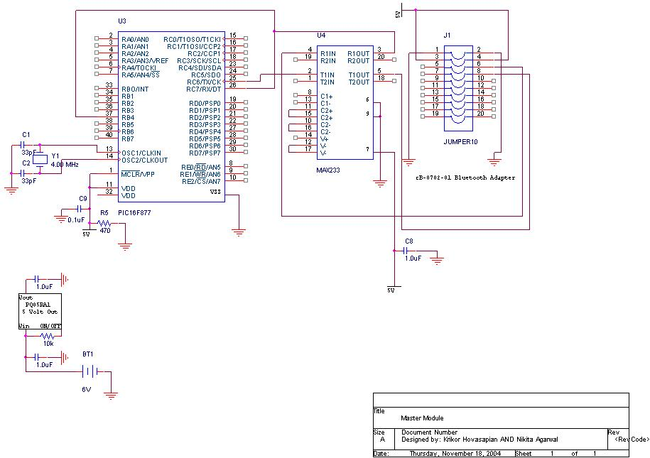

SCHEMATIC OF THE SLAVE NODE
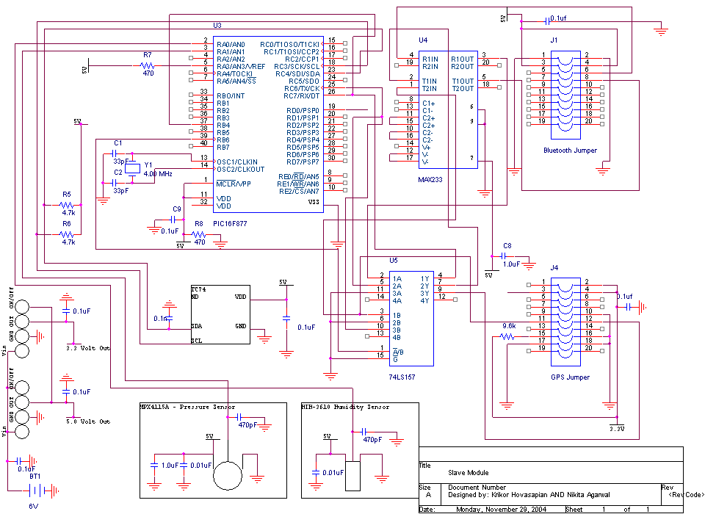

ECONOMICS – COST ANALYSIS
TOTAL COST OF THE PROJECT
PART NAME | UNIT PRICE | TOTAL
Blue Connect | $185 | 3X185 = $555
GPS | $45 | 3X45 = $135
Antenna | $20 | 2X20 = $40
Humidity Sensor | $30 | 7X30= $210
Pressure Sensor | $25 | 7X25= $175
PIC | $10 | 8X10= $80
Old GPS | $45 | 7X45= $315
Old Bluetooth | $40 | 7X40= $280
Old Demo Board | $300 | $300
PDA | $250 | $250
Battery | $9 | 3X9=$18
PCB Stuff | $55 | 2X55= $110
Surf Boards | $20 | 20$
Total Cost |  | $2,488

TOTAL COST OF THE PICONET
Cost of single node (Slave):
- Bluetooth: $185
- GPS + antenna: $45 + $20
- PIC: 10
- Humidity Sensor: $30
- Pressure Sensor: $25
- Battery: $9
- Surf Boards: $5
- MUX + Voltage Regulators ~ $5
- PCB: $30
- Labor: $0.75 (we work for cheap)
- Total: $359.75
Cost of Single Master
- Bluetooth: $185
- PIC:10
- Battery: 9$
- Surf Boards: $5
- MUX + Voltage Regulators ~ $5
- PCB: $30
- Labor: $0.75 (cheap labor)
- Total: $244.75
PDA = 250$
Total cost of the Pico net
(2 Slaves = 719.5) + (1 Master = $244.75) + (PDA = $250) ~ $1215
COST OF MASS PRODUCTION (Quantity of 1000 slaves and 500 masters)
Most of the parts, including the major parts like the Bluetooth and the GPS would cost around 85% of the original price. The total cost would come to around 1032$.
SAFETY, ETHICS AND HEALTH ISSUES
Safety

Bluetooth Module:

Bluetooth wireless technology makes it possible to use short-range wireless connections between mobile phones, laptops, printers, headsets, cameras and many other devices at home or at work. With Bluetooth wireless technology, cables are replaced by radio communications.
1. Bluetooth products contain small radio transmitters and receivers. The normal output power is very low, only 1mW (1/1000 of a watt), which gives a working range of about 10 meters.
2. The maximum exposure levels from Bluetooth products are well below the prescribed safety limits. Normal Bluetooth devices (1 mW) reach one hundredth of the safety levels at the most.
3. The risk of Bluetooth devices causing electromagnetic interference in sensitive electronic equipment, for example medical devices, is minimal because of the very low output power.
Temperature Sensor: The power consumption: The input voltage is 3.3 V and current is approximately 200 uA when communicating otherwise, 5 uA in standby, which is very low and is within the safety limits.
Pressure Sensor: The input voltage is 5 V and current is 7 mA, which is negligible.
Humidity Sensor: The input voltage is 5 V and current is 200mA.
GPS unit: The input voltage is 3.3 V and current is 65 mA.
The whole project is very low power and thus poses no danger as far as safety is concerned.
Ethics:
This project is the original idea of Dr. Das, Professor ECE, UNLV. We have modified the project the according to the practicality of operation and time constraints.
All the parts used have been bought from legal vendors online and/or from electronic stores such as Fry’s.
We hold the safety, health, and welfare of the public to be of extreme importance. This project is solely for the purpose of the completion of our class requirement ECG 498 in order to graduate and do research in wireless communications. We conduct our experiments honorably, responsibly, ethically, and lawfully so as to maintain the honor, reputation, and usefulness of the profession. We have developed out own codes and schematics entirely from scratch. We have documented all the sources according to the IEEE code of ethics. We understand and follow the doctrine that engineers uphold and advance the integrity, honor, and dignity of the profession.

AESTHETICS

The makeup or aesthetic of the project comes from the use of modules such as the Bluetooth module from ConnectBlue and the GPS module from Falcom. These two chips offer limited overhead for the designer and make life a lot easier when implementing into the design. One other great advantage is the compactness of the chips. We’re not dealing with large real estate in this project, so to use a Garmin GPS device in the WSN would make the overall look of each node very bulky. Remember, the goal is to keep things discrete when out in the field. No one wants to see the black box, but rather using the GPS module you should be able to determine where the device is relative to its location.
The PCB layout calls for a 2 inch by 2 inch design so the add on devices need to be properly placed inside the enclosure to keep the area under 4-5 in².
The enclosure of choice is a plastic container (regardless of color), and has the following dimensions: 2.5 x 2.5 x 1.5. We want the height to be give or take +/- .3 inches so that we’re able to mount the GPS and Bluetooth on the walls of the enclosure with proper screws (nylon). The system must reside in a plastic enclosure, and only in this type of material since the Bluetooth module calls for non-metallic casing to prevent attenuation of the signal.
One other key feature that should be taken into consideration is weatherproofing. The enclosure is plastic but plastic can be damaged in high temperatures, so making sure that a high grade of resistance to variables such as heat, rain and snow should be emphasized when ordering the proper enclosure.

SUSTAINABILITY
WSN is quite stable. However some design modifications must be made in order to expand on that sustainability and to create a more robust design. One of the issues right now is the battery being used. It’s a lithium camera batter by Panasonic, but is not rechargeable. So to make the device easier to operate and not have the issue of changing out batteries every so often, we need to implement a better power system. The power system that we have in mind for the next version of this product (or shall we say, the final product) is to build a solar panel either adjacent to the node, or tacked on top of the node. The solar power will continue to charge the battery during the day and operate under SLEEP conditions through the night. Chances are that data collection will be limited to the day, but this all depends on the application the user chooses.
One other reason why the design is sustainable is the use of add-on modules. We can easily swap the modules in and out of the circuit if need be, and with the inclination of the use in Bluetooth technology and GPS, it’s becoming easier to find these modules. Also as time progresses, the price of these modules is expected to come down with future releases.

MANUFACTURABILITY

If we’re concerned with mass production than we can justify our stances by saying the current version of WSN cannot be manufactured with profits in mind. One reason is the cost of the parts, namely the Bluetooth module that we’re using. Unfortunately, the vendor does not discount as handsomely as some other vendors do with other parts, so chances are that this maybe the first and last time the WSN will have this module on board. What we want to do is create a small enough board where the Bluetooth circuitry is integrated onto one PCB. This would mean a ball-grid chipset and the accompanying passive components must be applied. A qualifying product would be the LMX9820 from National or similar.

SOCIAL, POLITICAL AND ENVIRONMENTAL IMPACT

At this time it’s hard to assess any kind of social, political and or environmental impact. One scenario that’s possible is protest against wireless devices, emitting low levels of radiation in farmlands where farmers use WSN to monitor sensitive data. We can assure those critics that the low power being emitted by the device is not of any danger to the well-being of the crops in the vicinity. We can’t expect social outcry against WSN to lead to political movement against the networks use in the U.S farmlands.

FUTURE WORK

- To develop a Scatter net
- Add sensors such as touch, acceleration, optical etc.
- Possible addition of a CDMA module on one of the master units
- Use of Solar Power instead of a battery

CONCLUSION
We have a working prototype of the project. The sensor nodes or the slave nodes communicate with the Master node, and the output can be seen on the display. The project has been an overall very good learning experience. We would try to work on a publication for the project in coming future.

REFERENCES

- www.microchip.com
- http://ww1.microchip.com/downloads/en/DeviceDoc/30292c.pdf
- http://ww1.microchip.com/downloads/en/DeviceDoc/21462c.pdf
- www.connectblue.com
- www.digi-key.com
- www.newark.com
- http://www.gpsinformation.org/dale/nmea.htm#GGA
- http://pdfserv.maxim-ic.com/en/ds/MAX220-MAX249.pdf
- http://rocky.digikey.com/WebLib/Motorola/Web%20Data/MPX4250A,%20MPXA4250A%20SERIES.pdf
- http://catalog.sensing.honeywell.com/datasheet.asp?FAM=humiditymoisture&PN=HIH%2D3610%2D001
- http://focus.ti.com/lit/ds/sdls058/sdls058.pdf
- http://sharp-world.com/products/device/lineup/data/pdf/datasheet/pq05ra1_e.pdf

APPENDIX

DATASHEETS:

  - BLUETOOTH - CONNECTBLUE
  - GPS UNIT – FALCOM JP3
  - PIC16F877
  - TEMPERATURE SENSOR – TC74
  - PRESSURE SENSOR – MPX41150
  - HUMIDITY SENSOR – HIH 3610 001
  - MAX 233
  - VOLTAGE REGULATORS
  - MUX – 74LS157

OSCILLOSCOPE SHOTS

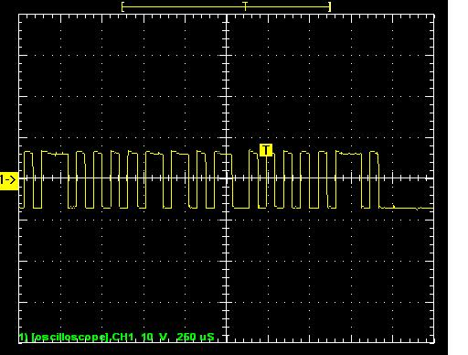
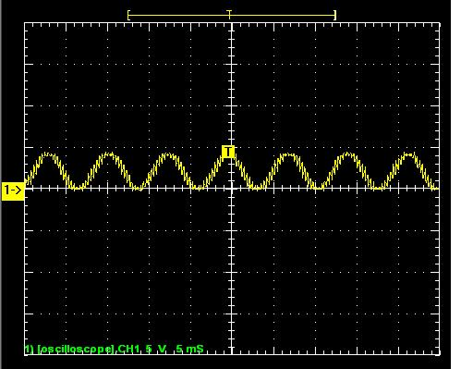

CLOCK WAKES UP PDA TO MASTER – WAKE UP CALL

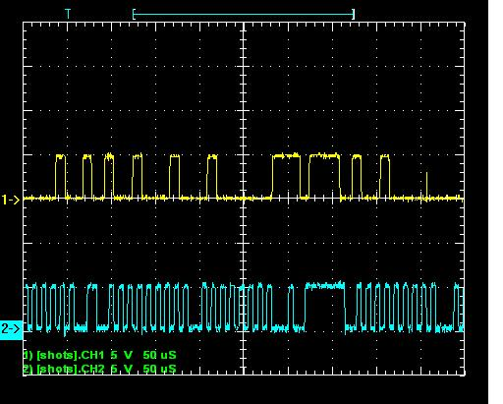
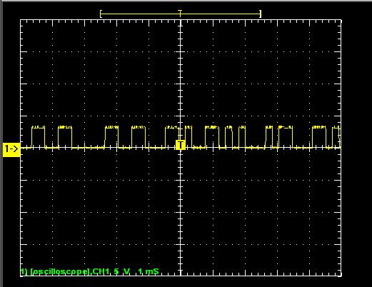

GPS SENDING OUT THE GGA DATA I2C
COMMUNICATION

PICTURES OF THE PROTOTYPE

