University & Community College System of Nevada

New Program Proposal Summary

Date: _______2/7/06______________________

Campus: _____UNLV________________________

Proposed Program: ____Astronomy Ph. D.____

Brief description of program:

The Astronomy Ph. D. program will provide students with classes and supervised research to prepare them for a career in Astronomy. The Astronomy degree program will build on the existing structure of courses offered by the Physics Department. It will offer the necessary additional courses so that students will be prepared for a career in Astronomy or related disciplines.

Demonstrated need for program (academic, state, regional, national):

Astronomy is a field of science closely related to physics though many universities offer degrees in both. The physics department currently has a core group of astronomers and this new degree program builds on that strength. The state of Nevada currently has no degree programs in astronomy. The job market in astronomy is expected to grow "as fast as average" according to Labor Department statistics.

Relationship of program to department, college, division, and System:

The Astronomy degree program will build on the existing structure of courses offered by the Physics Department. It will offer the necessary additional courses so that students will be prepared for a career in Astronomy or related disciplines.

Review of and impact upon directly related programs within the institution:

The most closely related degree program is the Ph. D. degree in Physics. Currently students wanting a degree in Astronomy pursue a Physics degree while doing physics research that relates to astronomy. The Astronomy Ph. D. degree Program would provide the additional option of pursuing an Astronomy Ph.~D replacing some of the physics requirements for astronomy requirements.

Estimated fall enrollment full-time equivalency (FTE):

1st year ___3_____ (estimate is sum of both MS and PhD students)
3rd year ___4_____
5th year ____6_____

Estimated fall headcount enrollment:

1st year ____3____

3rd year ___4______

5th year ___6______

Estimate of resources needed (personnel, library holdings, facilities, equipment):

The Astronomy graduate program with both the Master of Science and the Ph. D. will be ready to start after our astronomy hire this year (2006). After it is established another faculty would allow the program to carry more students.

Projected budget increases and additional costs to implement new program:

The Physics Department will be ready to implement this program with the new hire this year.

1st year ___$0_

3rd year ___$0_

5th year ___$0_

Source of funds:

none.

Is the new program listed in the campus academic master plan:

Yes.

Date Approved by Academic Affairs Council: ____________________

(Please attach to new program proposal)

University & Community College System of Nevada

Program Proposal Format

- Degree to be awarded upon completion of requirements; or title of department, school, or college to be initiated.

Degree Name: Doctor of Philosophy in Astronomy

Program Name: Astronomy Ph. D

- Proposed date of implementation.

Fall 2007

- Description of program or instructional unit.

The Department of Physics (the Department) at the University of Nevada, Las Vegas (the University) provides its students with several undergraduate and graduate programs in this fundamental area of study. Currently the Department offers three undergraduate programs,the Bachelor of Science in Physics, the Bachelor of Science in Applied Physics, and the Bachelor of Science in Computational Physics as well as two graduate programs, the Master of Science in Physics and the Doctor of Philosophy in Physics. The Bachelor of Science in Physics program prepares students for governmental or industrial positions as well as for graduate studies in physics or related areas. The Bachelor of Science in Applied Physics program is designed for students interested in interdisciplinary areas between physics and engineering that require a significant knowledge of physics. The Bachelor of Science in Computational Physics program is designed for students who would like a profession in using computers to do science. The graduate programs are aimed at educating students in physics research and preparing them for academic or other professional positions.

The Physics Department now has five astronomy faculty and it is a good time to expand into offering astronomy degrees as well as physics degrees. An informal survey of departments offering astronomy as well as physics degrees shows that they typically have between 6 and 8 faculty, suggesting we are in a good position to offer an Astronomy degree.

The proposed Doctor of Philosophy degree in Astronomy is intended to educate students in modern astronomical science. The students will have a broad and complete understanding of modern astronomical sciences. The students will be able to perform independent research on astronomical problems. The astronomy program will educate students hoping to teach astronomy or work at astronomical institutions as well as to prepare students for technical jobs requiring a greater understanding of science than an undergraduate degree.

- Statement of degree or program objectives.

The objectives of the astronomy degree program are to provide students with knowledge and understanding of astronomy. They will have had an overview of what is known about the universe and stars around us from specific topical courses on interstellar medium, active galaxies, cosmology, and stars. The students will also demonstrate the ability to carry out independent research.

- Plan for assessment of degree or program objectives.

The students enrolled in the program will be asked to comment on their coursework and experience with the program. On graduating they will be interviewed to determine employment prospects, and strengths or weaknesses of the program. This data will be used to modify the program through possibly new courses or requirements to better serve future students. The data will also be used to advise students enrolled in the program how to use the resources to best meet their needs.

Three years after the program has graduated its first students, a panel of colleagues in the related programs in the University & Community College System of Nevada and in other institutions will be consulted and solicited for comments on the success of the program and how it might be improved. Graduates of the program will be contacted to determine their needs and ensure the program addresses them.

The program will also be assessed by the regular assessment processes the Department of Physics uses for its current programs. Reports on progress, graduates, and other related aspects will be given to the Department. If there are any problems with the program, the Department will take action to address them.

- Plan for assessment of student learning outcomes and the use of this data for program improvement.

In addition to the student exit interviews students will be tracked for several years and interviewed to determine how the program has helped them and how it could of better served their needs. As a result of these interviews the courses may be modified, new courses added, requirements changed or advice to current students changed, so that the program can best meet the needs of the students.

- Contribution and relationship of program objectives to:

UCCSN Master Plan

The proposed program will provide a excellent learning experience for students as well as help Nevada develop and sustain a knowledge based economy as stated in goals 1 and 2 of the master plan. The Ph. D. program will add to the diversity of programs offered by the system, thus helping it to fufil its first goal of using instruction and research to help develop a knowledge-based economy. It also will help the system provide an excellent intruction and research by building on the astronomy research program which already exists.

- Institutional mission.

The University expects a high level of scholarship from its faculty and students, as pointed out by the mission statement in its Academic Master Plan. The requirements in the proposed program are tailored carefully to meet the highest standard among all similar programs world-wide. A significant number of graduate courses in Physics are required while maintaining a flexibility for developing personalized options to ensure that the students enrolled in the program will gain extensive knowledge in astronomy and physics as well as skills in written and oral communication, computing, problem-solving, and working with a team, which are essential for a successful career.

This new program will also help the University in achieving several of its missions. For example, the University has an important role in the Las Vegas metropolitan area, the state of Nevada, and the southwestern United States, in providing general and specialized education to their residents and qualified graduates to the companies, firms, and other organizations in the area. A first-rate astronomy program offering a Ph. D. will provide residents in the area an unprecedented opportunity for advancing their knowledge.

It directly addresses many of the goals of the University, int particlular it will raise the national awareness of the astronomy program thus helping the university with its third goal of of trying to raise national recognition. It is also helpful in goal 8 of the university, because astronomy programs tend to be computationally intensive and having a bigger group will make it easier to compete for funds to get specialized computing for our students.

- Campus strategic plan and/or academic master plan.

One of the goals set in the Academic Master Plan of the University is to seek selective growth in degree programs based on the need and demand of the students, resources available, and state of readiness. The proposed astronomy program is the first of its kind in the state of Nevada and will certainly create a new competitive learning environment in scientific computing, fostering more computational science and computational engineering programs from other departments and colleges in the future.

Another of the universities goals is to achieve national recognition, the addition of an astronomy Ph. D. program will increase the awareness others have of UNLV. The astronomy program is most directly connected with the Informatics Macrotheme in that astronomy is mostly about information collecting and manipulating information on computers.

The University has decided to utilize its existing resources to a better extent, as stated in its Academic Master Plan. The Department has been active in astronomy for many years and has been successful in obtaining extramural funds. Faculty research interests include star formation in galaxies, active galactic nuclei, ring galaxies, clusters of galaxies, large scale structure of the universe, stellar atmospheres, nucleosynthesis and variable stars. The Department is part of the Nevada Space Grant Consortium, the purpose of which is to develop research and educational opportunities in space science in Nevada. The department is also part of a four-college consortium that operates an automated telescope on Mt. Hopkins, near Tucson, Arizona. UNLV astronomers successfully compete for observing time on the Hubble Space Telescope and at the various national astronomical facilities, such as the National Optical Astronomy Observatory. On-site departmental facilities include a 16-inch computer-operated photometric teaching telescope mounted on the roof of the Bigelow Physics Building, personal computers and workstations dedicated to digital processing of astronomical images, as well as a Computational Cluster bought with money from the W. M. Keck Foundation.

- Department and college plan.

The Department currently has five faculty members actively supervising graduate students in research in Astronomy and Astrophysics. A program built on their expertise will stimulate more students to participate in an active learning process and to gain first-hand experience by working with these faculty members.

- Other programs in the institution.

We do not anticipate significant impact of this new program on the existing programs in the University since there is not an astronomy program in the University. The required courses in graduate physics are expected to cause an increase in the enrollment of those courses.
- Other related programs in the System.

There are no related programs in the System. University of Nevada, Reno does not have an astronomy degree program, nor any astronomy research program.

- Articulation issues (within the institution).

The program would coexist with the physics Ph. D. program, supplementing physics courses with those required for an astronomy Ph. D.

- Evaluation of need for the program.

- Intrinsic academic value of program within the discipline.

The proposed Doctor of Philosophy in Astronomy is intrinsically valuable because it addresses the needs of students with interests in astronomy desiring to pursue this goal. The curriculum designed for the program takes advantage of the existing Doctor of Philosophy in Physics program to allow students to tailor their physics and astronomy education to their career needs. Compared with a half dozen such programs across the nation and the world, the program will be extremely competitive, since we already have several active research faculty. Through the offering of this new program, the University will add another high-quality education area to its current programs for better service to Nevada residents and others. Graduates from this program will have a solid background in both physics and astronomy.

The introduction of the program will increase the level of recognition of the University and the Department among other educational institutions and the scientific community. It will increase our ability to educate students in an area where we have already had success placing students.

- Evidence of existing or projected local, state, regional, national and/or international need for program.

The projected growth by the United States Department of Labor outlook for astronomy jobs to grow betwe ten 3 and 9% between 2002 and 2012, They also point out astronomy degree holders are qualified for many technical jobs outside their field. The American Astronomical Society has seen more then doubling in the number of jobs posted in their job register since 1995.

Although most astronomers work at universities or in government jobs some work for private industry, either directly on astronomy related items such as sattelites meant for astronomy research, or in related areas such as remote sensing, spectral observations, or applying computers to solve problems. In addition, astronomers work in public outreach jobs, such as planetariums or museums.

- If this or a similar program already exists within the System, what is the justification for this addition?

No similar programs.

- Evidence of employment opportunities for graduates (state and national).

The Physics Department has already graduated a number of M.S. and Ph.D. students who have worked with astronomy faculty and whose theses and dissertations have been on topics of astronomical interest. All these students are fully employed. For example of the three astronomy based Ph. D.'s granted, one is an associate professor at a state university, one initially worked on software for the gaming industry and has since transitioned into software training, and the third is in the Air force and applying for the astronaut program.

- Student clientele to be served.

Currently the physics department has students pursuing Doctorates in Physics with a thesis which relates to astronomy. It has also had students who have stopped at the masters, or only enrolled as special students, because they wanted an astronomy degree. This program will allow us to be more flexible in admitting and designing degree programs for students interested in getting an astronomy
doctorate at UNLV. It will better suit the needs of students by allowing an additional option of an astronomy degree. In addition, because physics requirements are replaced by astronomy requirements, this program can be more flexible in accepting students from other disciplines who have an abiding interest in astronomy.

A small survey of our current physics students, five in number, who are doing astronomy research found that 100% would have been interested in an astronomy degree if we had one. In addition, an analysis of the inquires that the physics department received on Fall of 2003, about 30 in number, show that about 40% of those who expressed a preference chose astronomy as their prefered area.

- Procedures used to arrive at the decision to propose the program.

A survey of Departments in the American Physical Society lists suggest that departments offering both physics and astronomy degrees typically have between six and eight professors specializing in astronomy. These relatively small numbers are possible because of the strong overlap between physics and astronomy allowing the program to draw on classes from each discipline. The Department currently has five faculty members who have astronomy related research. This suggests UNLV is ready to add astronomy degree programs to the physics degree programs.

- Detailed curriculum proposal.

A. Representative course of study by year (options, courses to be used with/without modification; new courses to be initiated).

Fall Year 1:
Introduction to Astrophysics I (AST 700): 3 credits
Quantum Mechanics I (PHY 721): 3 credits
Mathematical Physics (PHY 700): 3 credits
Seminar (Ast 796): 1 credit
Semester Total: 10 credits

Spring Year 1:
Introduction to Astrophysics II (AST 701): 3 credits
Observational Astronomy Techniques (AST 710): 3 credits
Mechanics (PHY 702): 3 credits
Seminar (Ast 796): 1 credit
Semester Total: 10 credits

Fall Year 2:
Thesis 3 credits
Electricity and Magnetism (PHY 711): 3 credits
Seminar (Ast 796): 1 credit
Semester Total: 7 credits

Spring Year 2:
Interstellar Medium (AST 747): 3 credits
Optional PHY or AST course 3 credits
Thesis 3 credits.
Semester Total: 9 credits

Fall Year 3:
Optional PHY or AST courses: 6 credits
Seminar (Ast 796): 1 credit
Semester Total: 7 credits

Spring Year 3:
Dissertation (AST 799): 6 credits
Seminar (Ast 796): 1 credit.
Semester Total: 7 credits

Fall Year 4:
Dissertation (AST 799): 6 credits
Seminar (Ast 796): 1 credit
Semester Total: 7 credits

Spring 4:
Dissertation (AST 799): 6 credits
Optional PHY or AST course: 3 credits
Semester Total: 9 credits

This student represents a typical student completing the program, the student has completed 66 credits and obtained both a Masters in the second year and a Ph. D.. The student has done the minimum required to get both degrees.
This student would have finished a thesis masters after the second year of study. It is typical for our students to get a masters on the way to a Ph.D., though not a requirement . A student not getting a Thesis Masters could drop the Thesis Credits in the second year and still fufil the requirments for a Ph. D. in Astronomy.

A student who has a masters may be admitted to the Ph.D. Program, though our experience in physics shows this to be less common then students with just an undergraduate degree. In such a case a student who has been admitted with a masters in Physics or Astronomy, may just complete a program like the last two years of the program outlined above. A student admitted with a Masters in some other area is likely to have to complete all four years of the program above, though the thesis credits in the second year could be dropped if the student has no wish to get a second Masters. Such programs really need to be designed on an individule basis, to determine what courses may be transfered from their M.S. Program . They will then be required to fulfill the rest of the requirements.

The courses the program uses already exist.

B. Program entrance requirements.

Applicants should have an undergraduate degree or a Masters degree in Physics, Astronomy or related areas. Applicants must have a minimum grade point average of 2.75 for all undergraduate work or a minimum 3.00 grade point average for the last two years of undergraduate work. In addition, applicants seeking direct admission to the doctoral program without a previously earned Master of Science degree must have a score in the 65th percentile or above on the Advanced Physics portion of the GRE before admission and have a minimum GPA of 3.00 for all undergraduate work or an overall 3.25 GPA for the last two years of undergraduate work. Applicants with a master's degree must have an overall 3.00 GPA in their Master's program and at least 15 credit hours of graduate-level course work in physics or astronomy with a grade of B or better. A student entering with a Masters will be required to complete at least 30 additional credits, including dissertation credits, beyond the Masters.
C. Program completion requirements (credit hours, grade point average; subject matter distribution, prerequisites).

A total of 60 graduate credits past the bachelor's level is required,
including the following:

- A minimum of 36 graduate-level semester credits in astronomy or related fields (excluding doctoral dissertation and graduate seminar), which must include the following core courses:

AST 700-701 Introduction to Astrophysics

PHY 702 Mechanics or PHY 721 Quantum Mechanics

PHY 700 Mathematical Physics

and at least 3 courses from

AST 710 Observational Astronomy Techniques

AST 721 Gaseous Nebulae and Active Galactic Nuclei

AST 727 Cosmology

AST 731 Stellar Atmospheres

AST 747 Interstellar Medium

AST 771 Special Topics

Six of the 36 credits must be taken in the fourth or fifth year. Course work used to satisfy the requirements for a master's degree may be included. A minimum grade of B- is required in each course. An overall grade point average of 3.00 or better is required in all course work which is part of the degree program. Course work taken outside the Physics Department must have departmental approval. Doctoral and Master's degree candidates take many of the same courses.

- Six credits of AST 796, Graduate Seminar, including three acceptable presentations by the student.
- A minimum of 18 semester credits of Astronomy 799, doctoral dissertation.
- Satisfactory performance on an astronomy qualifying examination on graduate astronomy knowledge. Must be fulfilled by the second year in the program. The examination will consist of graduate level astronomy problems from the core courses, of which the passing student will be expected to aswer at least half.
- A dissertation of high quality consisting of significant original research.
- Satisfactory performance on a final examination which will consist of an oral defense of the dissertation. The student will be expected to defend their dissertation as well as show a command of how their research connects to other astronomical research.

A student who enters the doctoral program with a master's degree must satisfy all of the above requirements numbered 1-6. The exact number of graduate semester credit hours past the master's degree will depend upon the quality of the student's preparation and the rate of progress during research. All courses used to satisfy the course work requirement (listed as l. above) must have the approval of the Physics Department. The number of graduate credits beyond the master's level must be at least 30; typically it will be more.

D. Accreditation considerations. Organization (if any) which accredits program. Requirements for accreditation. Plan for attaining accreditation. Include costs, time frame.

There is no separate accrediting organization for astronomy programs.

E. Evidence of approval by appropriate committees of the institution.

The proposal has been approved by the Physics Department and the College of Science.

- Readiness to begin program.

A. Faculty strengths (specializations, teaching, research, and creative accomplishments.

The faculty in the Department are mainly specialized in three major fields, (1) astronomy and astrophysics, (2) atomic, molecular, and optical physics, and (3) condensed matter physics. In each of the three fields, there are faculty members who are experts in computer simulation and modeling.

The Department offers a complete curriculum of physics and astronomy courses that range from algebra-based Introductory Astronomy and General Physics to advanced special topics in current research in physics and astronomy.

The faculty of the Department publish regularly in leading refereed journals and their research projects are widely supported by the National Science Foundation, the Department of Energy, and the National Aeronautics and Space Administration. One of our faculty is on the STIS Instrument Definition Team for the Hubble Space Telescope. Other faculty have received guest observing time on Hubble and other world-class telescopes.

The primary faculty involved in the program will be Stephen Lepp, George Rhee, Dianne Pyper-Smith, Daniel Proga and Bing Zhang along with the additional hire required to start the program. The particular strengths these faculty bring are listed below.

Stephen Lepp primarily researches in astrophysical modeling involving atomic and molecular physics. He has worked much on the Interstellar Medium and Star forming regions, as well as the Early Universe and Supernova. He has been principal investigator on approximately 1.3 million dollars in grants and was part of the team that brought in a 450,000 dollar equipment grant from the W. M. Keck Foundation. He has published over 60 papers, book chapters and reviews.

George Rhee works primarily on the structure formation in the universe. He has published over 30 papers and many conference proceedings. He has been principal investigator on tens of thousands of dollars in grants.

Dianne Pyper-Smith main research is photometry studies of variable stars, she has been principal investigator or co-investigator on over a half a million in grants and has published over 30 papers.

Bing Zhang works in High Energy Astrophysics. He has over 40 refereed papers and is principal investigator on over half a million dollars in grants. He is on the team for the SWIFT satellite.

Daniel Proga works in Astrophysical Fluid Dynamics. He has over 30 refereed papers and is principal investigator on grants from NASA.

B. Contribution of new program to department's existing programs (both graduate and undergraduate) and contribution to existing programs throughout the university.

The proposed program will provide for astronomy education at UNLV. As the first astronomy program in Nevada, the proposed program will expand the opportunities for students studying in Nevada.

C. Completed prior planning for the development of the program (recent hires, plans for future hires, securing of space, curricular changes, and reallocation of faculty lines).

The "Introduction to Astrophysics", "Interstellar Medium'' , "Astrophysics of Gaseous Nebulae and Active Galactic Nuclei'', "Observational Astronomy Techniques'', "Stellar Atmospheres'' and "Cosmology'' courses have already been developed and offered. The only other courses which need to be submitted are largely administrative courses such as:
AST 771 "Special Topics'',
AST 777 "Advanced Special Problems'',
AST 796 "Graduate Seminar'',
AST 797 "Thesis'' and
AST 799 "Doctoral Dissertation''.

D. Recommendations from prior program review and/or accreditation review teams.

None.

E. Organizational arrangements that must be made within the institution to accommodate the program.

None.

- Resource Analysis.

A. Proposed source of funds (enrollment-generated state funds, reallocation of existing funds, grants, other state funds).

The program, consisting of both the Astronomy Ph. D. and Astronomy M. S. degrees, will require no new faculty lines. The lines needed to teach the courses
are already available.

B. Each new program approved must be reviewed for adequate full-time equivalent (FTE) to support the program in the fifth year. Estimate the following:

1. full-time equivalent fall enrollment for the first, third, and fifth year.

Year 1, 3 students. Year 3 4 students, Year 5 6 Students.

2. total headcount fall enrollment for the first, third, and fifth year.

Year 1, 3 students. Year 3 4 students, Year 5 6 Students.

NOTE: Actual FTE and headcount enrollment must be reported after program commencement for first, third, and fifth year. An initial program review is due at the conclusion of the fifth year.

C. Budget projections (revenue and expenditures) for each of the first three years, including:

1. revenue and expenditures associated with the program itself,
none.

- institutional financial support to be reallocated to accommodate the program,
none.

3. full-time equivalent (FTE) faculty,
One for the program to expand at some future time.

4. classified staff, professional staff, and graduate assistants,
No additional classified staff members are requested for the program under the assumption that the existing classified staff positions will not decrease or be suspended over time. No additional supporting staff members are requested to begin the program, assuming that the Department will have successfully converted its half-time Computer System Programmer into a full-time position.

5. operating funds,
No additional operating funds are requested for the program.

6. library and information resources, and
The current library holdings are adequate for the program.

7. other.

D. Estimated budgetary and financial ramifications for the institution.

No significant budgetary or financial ramifications are anticipated for the University by introducing this new program because the amount of initial funding requested is relatively small and possible future support is in line with the selective growth of the Academic Master Plan of the University. The Department will also actively seek extramural funds to support the program as it has done for its other programs in the past.

E. Impact of new program on department's existing resources.

The proposed program will share most of the Department's resources with other existing programs in the Department. The plan is to better utilize the existing resources and better fulfill the mission of the University within the available resources. The introduction of the program will, however, require the Department to allocate its resources efficiently and divide its efforts among all the programs.

NOTE: Actual costs associated with the program must be reported after program commencement for first, third, and fifth year. An initial program review is due at the conclusion of the fifth year.

- Facilities and equipment required.

A. Existing facilities: type of space required, number of assignable square feet, space utilization assumptions, special requirements, modifications, effect on present programs.

None.

B. Additional facilities required: number of assignable square feet, description of space required, special requirements, time sequence assumed for securing required space.

None.

C. Existing and additional equipment required.

None.

- Student services required.

A. Plans to provide student services, including advisment, to accommodate the program, including its implications for services to the rest of the student body.

The student services will be similar to those already provided in Physics for their Physics Ph. D Students.

- Consultants (required for university programs only).

A. Names, qualifications and affiliations of consultant(s) used.

Alexander Dalgarno, Phillips Professor of Astronomy, Harvard University. Professor Dalgarno is one of the most distinguished members of the Astronomical community, he served as Editor of the Astrophysical Letters, is a Fellow of the Royal Society, a member of the National Academy and has won numerous awards and has an asteroid named after him.

H. Richard Miller, Professor Georgia State University. Professor Miller is a distinguished astronomer and is also the director of Georgia States Graduate Program in Astronomy.

B. Summary of consultants comments and recommendations.

Because of the relation between the Astronomy M. S. and Astronomy Ph. D. the two consultants where asked to comment on both programs. The consultants were both enthusiastic over the new programs. The first stated that the proposals have been "intelligently constructed to make efficient use of university resources and with additional support a program of national significance can be created". The second stated he "enthusiastically supported both programs" and has "every expectation they will be quite successful".
C. Summary of proposer's response to consultants.

We have added an additional faculty to support the
programs in response to consultants suggestions.

D. Attachment of consultant's complete report.

- Articulation Agreements

A. Articulation agreements were successfully completed with the following UCCSN institutions. (Attach copies of agreements)

B. Articulation agreements have not yet been established with the following UCCSN institutions. (Indicate status)

C. Articulation agreements are not applicable for the following institutions.

No other UCCSN institute have any astronomy program.

Summary Statement

The Doctor of Philosophy in Astronomy degree is primarily intended to provide students with an expertise in Astronomy. It is common for Physics Departments with astronomy programs to offer advanced degrees in astronomy. The proposed program builds on an existing strength in the Department of Physics and diversifies our offerings to help us better serve the community.
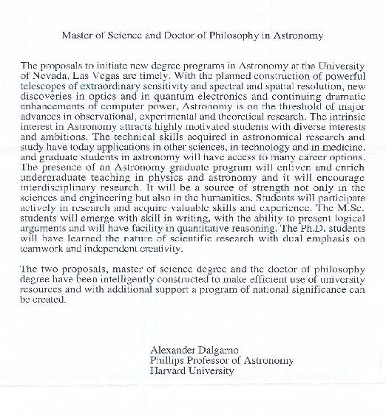
Here are scanned copies of the external letters. The reviewers were asked to comment on both the Astonomy M. S. degree and the Astronomy Ph. D. degree.

Here is the letter from Professor Dalgarno:
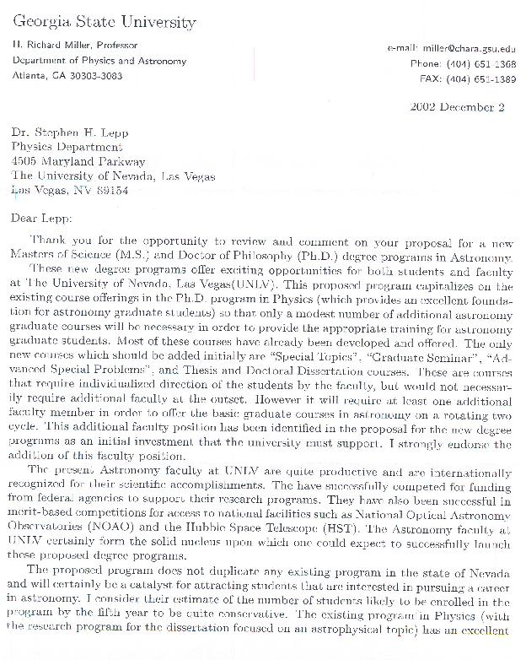
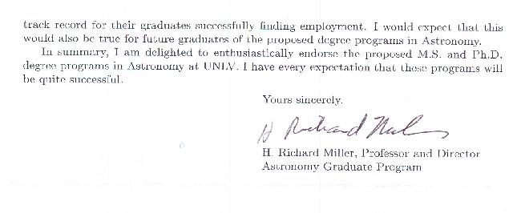
Here is the letter from Professor Miller:

second page:

